

**Boston University**

**Electrical & Computer Engineering**

**EC464 Capstone Senior Design Project**

User's Manual

The Future of Heat

Submitted to

Petersile, Marissa

National Grid, 40 Sylvan Rd, Waltham, MA 02451

Marissa.Petersile@nationalgrid.com

By

Team #17

Future of Heat

Team Members

Fatima Dantsoho [dantsoho@bu.edu](mailto:email1@bu.edu)

Andrew Chen achen17[@bu.edu](mailto:achen17@bu.edu)

Ben Gross [bengee19@bu.edu](mailto:bengee19@bu.edu)

Muayad Al Riyami [mriyami@bu.edu](mailto:mriyami@bu.edu)

Seunghak Shin [seunghak@bu.edu](mailto:seunghak@bu.edu)

Submitted: (4/15/2021)

The Future of Heat

Table of Contents

**Executive Summary** **3**

**Introduction** **4**

**System Overview and Installation** **5**

Overview block diagram 5

User interface 6

Physical description 7

Installation, setup, and support 8

**Operation of the Project** **10**

Operating Mode 1: Normal Operation 10

Operating Mode 2: Abnormal Operations 10

Safety Issues 11

**Technical Background** **12**

Web Application 12

Circuitry 14

Arduino + ESP8266 Wifi Module: 15

**Relevant Engineering Standards** **16**

**Cost Breakdown** **17**

**Appendices** **18**

Appendix A - Specifications 18

Appendix B – Team Information 19

Appendix C – References 19

# 

# 

# 

# Executive Summary

As global warming is becoming more severe, non-renewable energy such as natural gas and oil is falling out of favor. Using natural gas and oil to heat homes and businesses only continues to accelerate the warming of our planet. One of the promising alternatives is using electricity for heating. So we were tasked by National Grid to create an educational model that will teach the public about the benefits of electric heating and how it will affect grid systems in the future. This educational device is planned to be showcased in Worcester, Mass. – in National Grid’s Sustainability Hub building.

Team 17’s approach to this problem includes a two part teaching tool, a diorama and an interactive web application. The diorama provides users with an appealing visualization of the grid, and the interactive web application allows users to interact with the diorama with ease.The final deliverable is a 3 feet by 3 feet diorama with built-in electronics which will be accompanied by an interactive web application. We decided to focus on heating simulations that would behave accordingly to the user inputs and programmed into the microcontroller. The outputs will be displayed using LEDs on the diorama as well as through the web application on the user’s screen.

A major innovative feature of this project is that it accommodates for the safety protocols regarding the pandemic by creating a contactless but interactive learning experience. Users can simply scan the QR code with a mobile device and use the web application to interact with the diorama to learn about the future of heat!

# Introduction

The electric and gas utility company, National Grid has a problem regarding modeling the effects of the newer trends in electric heating adoption and electric vehicle adoption on the power grid. As such, our client Ms. Petersile requires an interactive educational model that demonstrates the impact electric heating and peripherally electric vehicles will have, focusing on the following key metrics: carbon emissions, cost savings, and power demand.

With the current rate of human-caused carbon emissions, climate change not only threatens our current way of life, but our future as well. The current usage of natural gas-powered heating in commercial buildings and homes is a major contributor to anthropogenic carbon emissions. According to the EPA, commercial and residential heating of buildings contributes to at least 12% of GHG emissions. Robust methods to decarbonize heating are needed, one of which is the introduction of electric heating. These new types of electrical heat pumps are viable and sustainable for wide scale adoption. In addition, if the electricity used to power these heat pumps is sourced renewably, then the future of heat can be completely emission-free. Therefore, substantially reducing waste and pollution while gaining efficiency.

The Future of Heat project will demonstrate the impacts of electric heating on carbon emissions savings, the power demand on the grid, and the cost savings of installing electric heating. In summary, the Future of Heat project will provide an interactive educational tool that can teach the public about the benefits of widespread adoption of electric heating and why it is the wiser choice for the future.

Team 17’s approach to this problem includes a two part teaching tool, a diorama and an interactive web application. The diorama provides users with an appealing visualization of the grid, and the interactive web application allows users to interact with the diorama with ease.

The interactive web application will allow users to select various parameters to be tested. Once the user inputs are submitted, the web application will display the corresponding data and graphs that highlight the benefits of electric heating. Our users will also be able to observe real-time changes to the diorama, as LEDs will turn on, off, or change colors. The combination of a user-friendly web application and a dynamic and aesthetically-pleasing diorama will ensure an enjoyable learning experience for the users.

# System Overview and Installation

## Overview block diagram

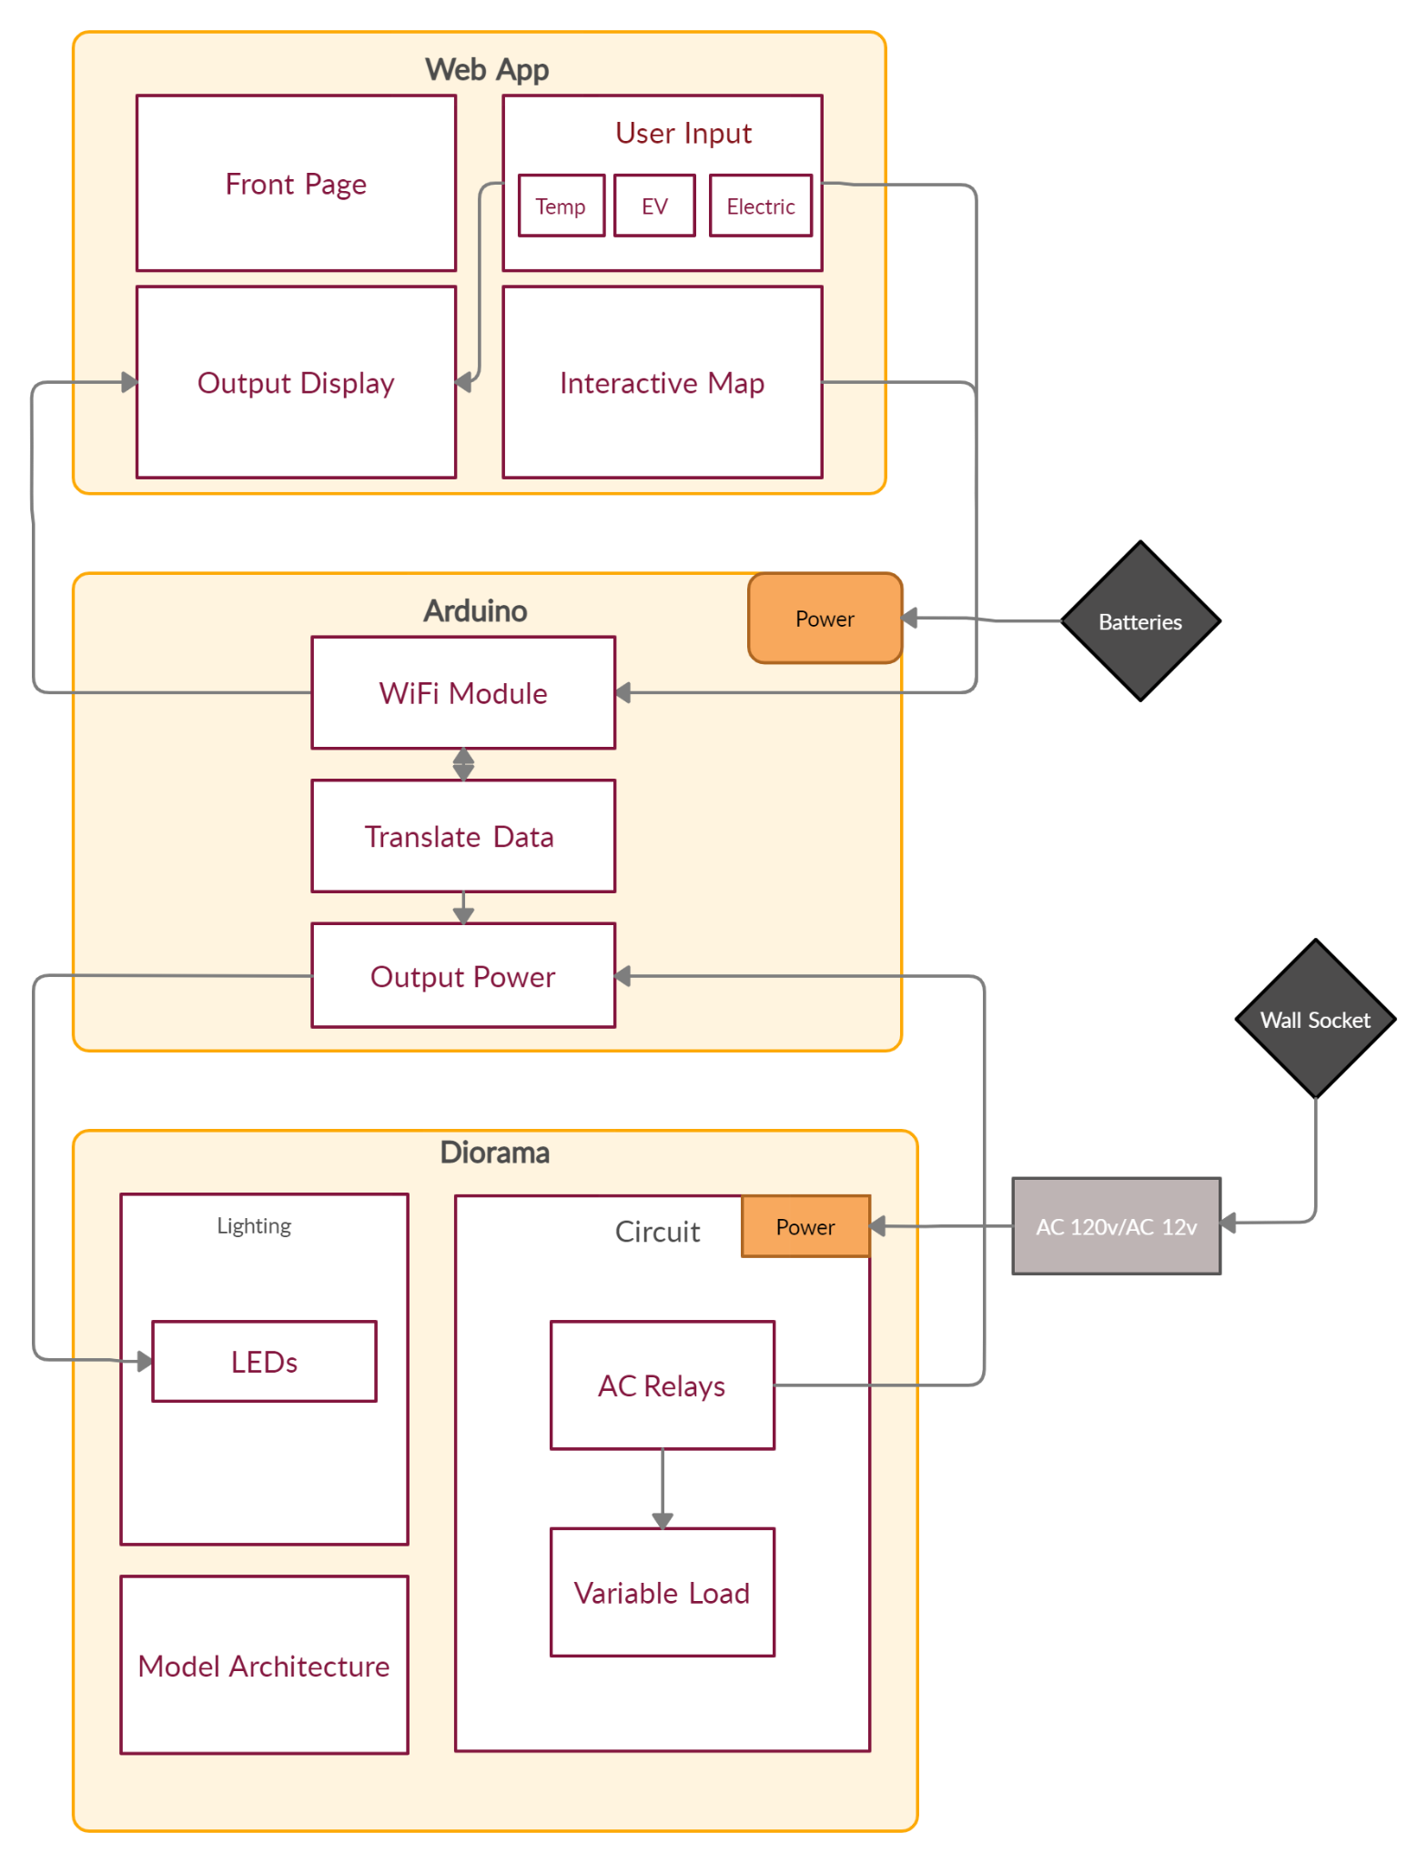

*Figure 2.1 System Block Diagram. The system is made up of three main components: the web application, which has the user interface and data processing, the diorama and circuitry, and finally the Arduino, which serves as the link between the web application and the diorama as it controls all LEDs and variable loads.*

## User interface

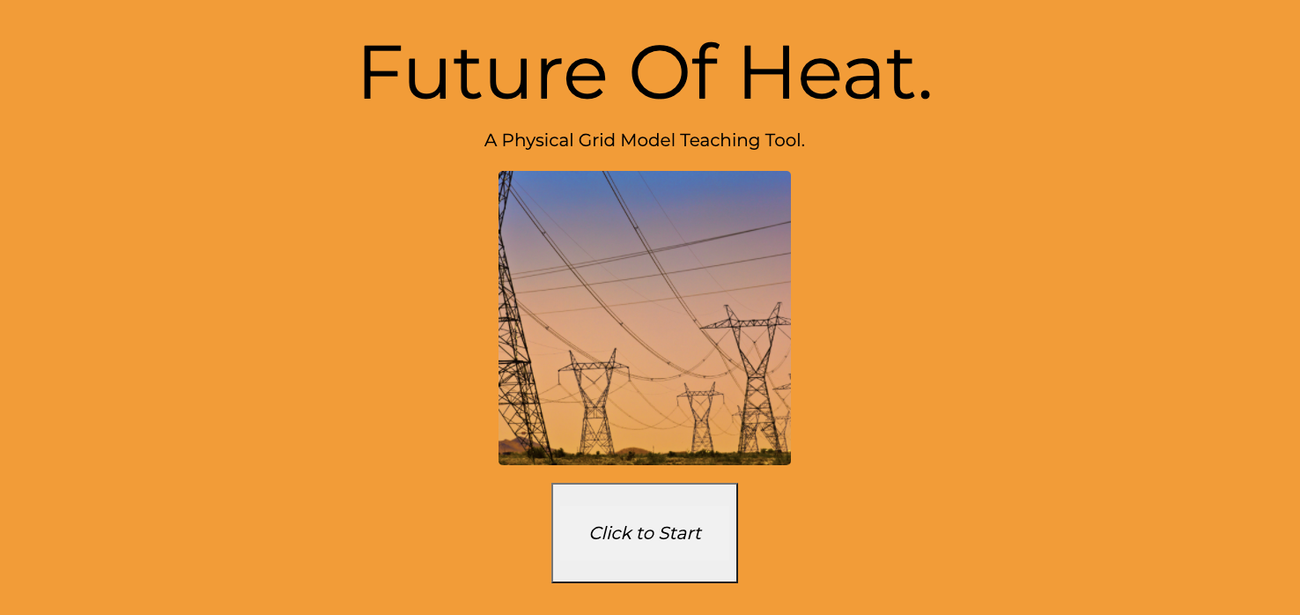

*Figure 2.2 Web application front page.*

*“Click to Start” button on this page clears the database for a new user to begin testing.*

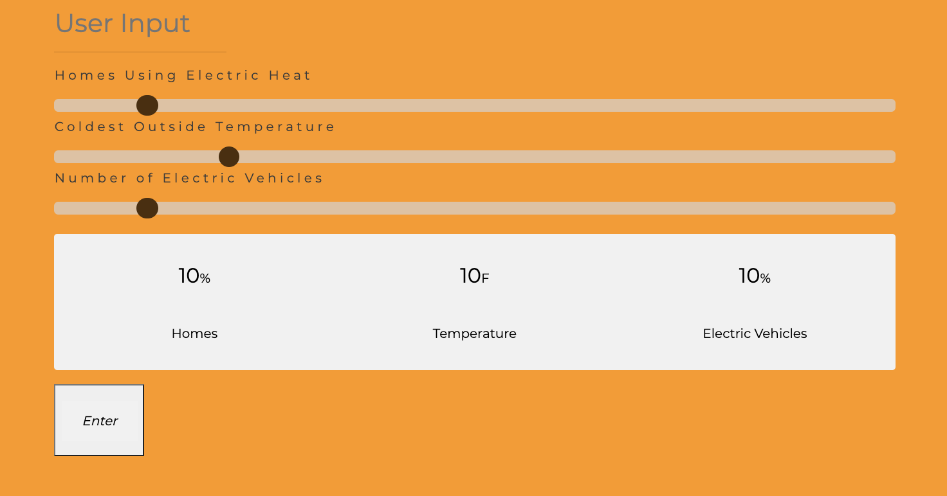

*Figure 2.3 User interface, user inputs.*

*The user selects the adoption rates and outside weather using range sliders. The changes will be reflected by the LED color change in the diorama.*

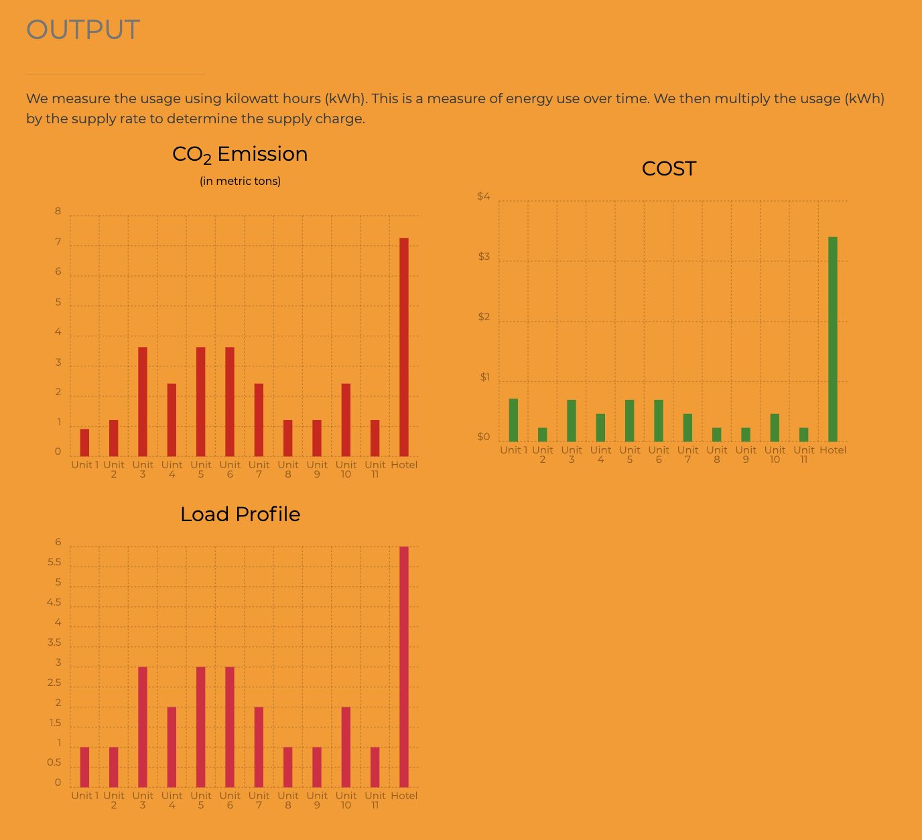 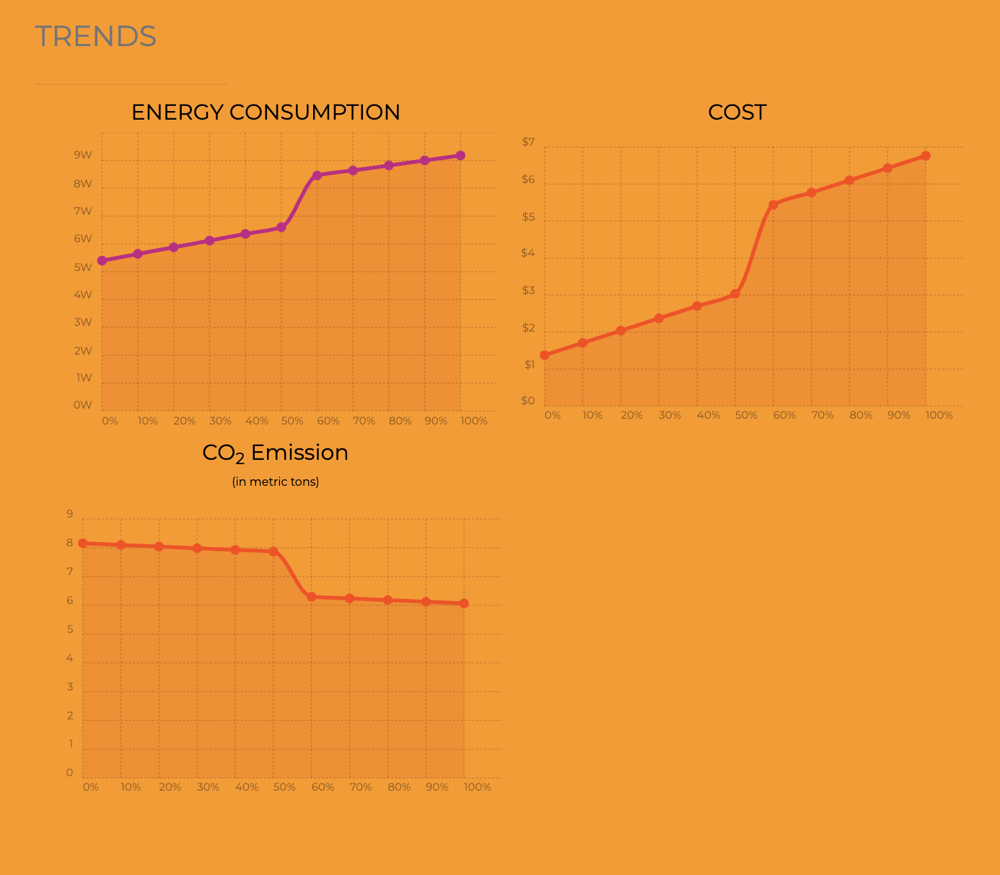

*Figure 2.4 and Figure 2.5 Output Graphs.*

*These figures show the two charts sections for the user output: figure 2.4 is the individual CO2 emissions, cost and energy profile of each building and figure 2.5 is the CO2 emissions, cost and energy consumption trend graphs.*

## Physical description

As seen below in *Figure 2.6,* the diorama consists of 11 residential houses, 1 hotel, and one power plant. The hotel is isolated from the residential houses, while the power plant is connected to all the residential houses through a series of roads. There is a semi-realistic forested area hiding the power plant from view of the houses. The hotels and residential houses have two color changing LEDS each. The LED on the roof alternates between green and red to indicate electrical and gas heating respectively. The secondary LEDs, located inside each house gradually transition from blue to red to indicate heating. These LEDs are controlled reading web app inputs using the Adafruit ESP8266 Huzzah Wifi and transmitting them to Arduino Mega 2560. Both of which can be seen in *Figure 2.7* and *Figure 2.8.*

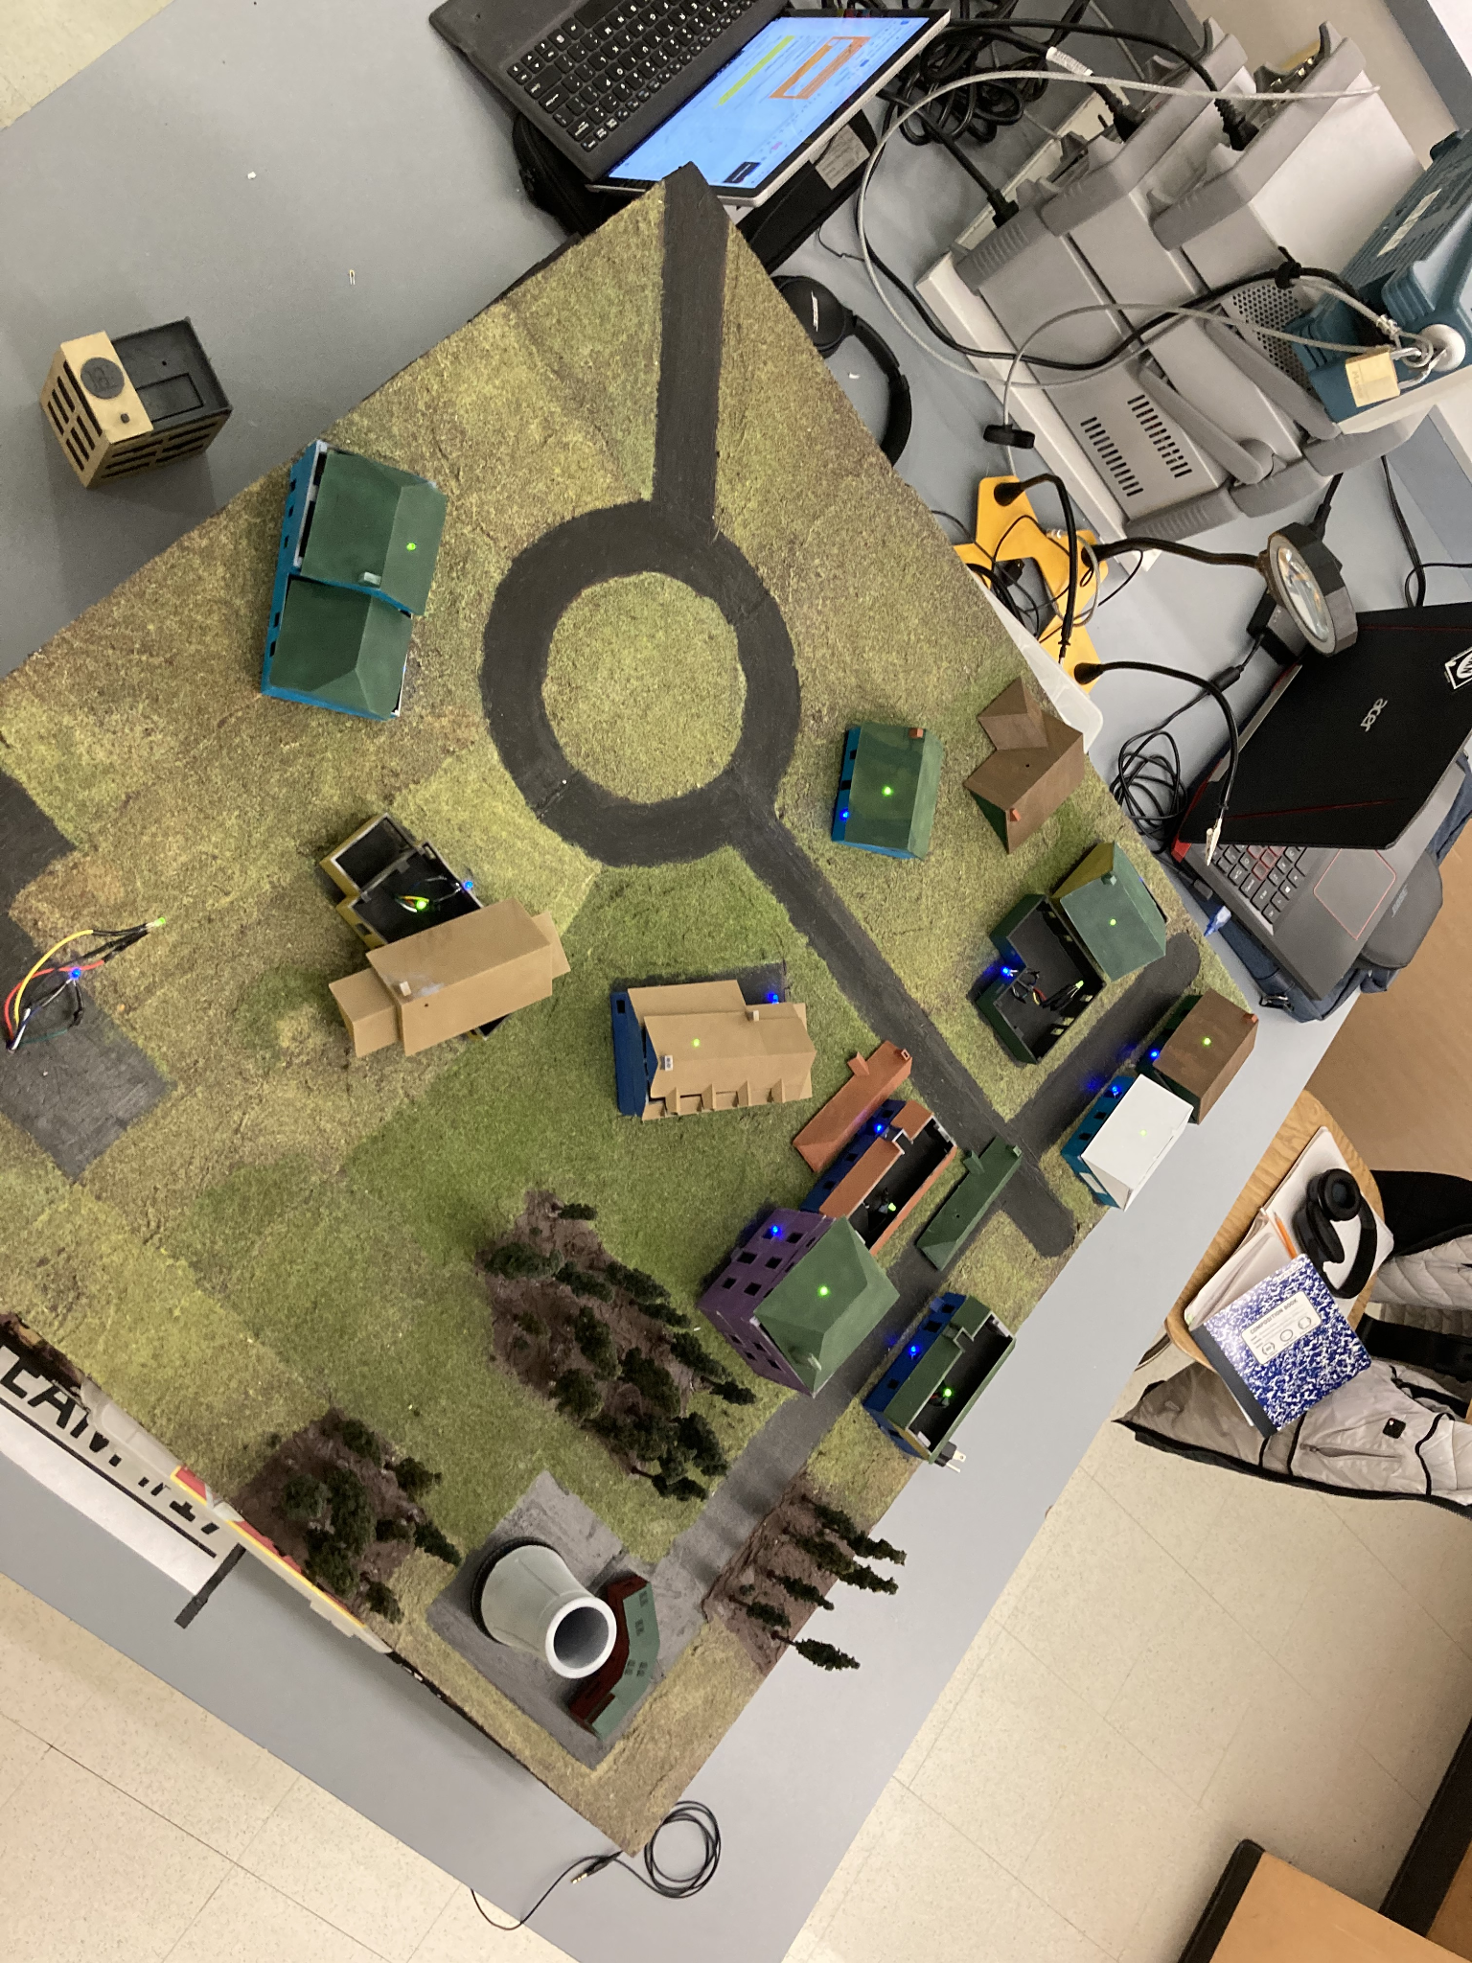

*Figure 2.6 Top view of the Diorama.*

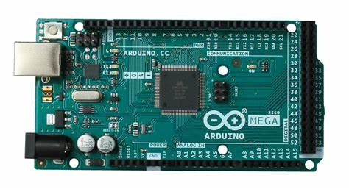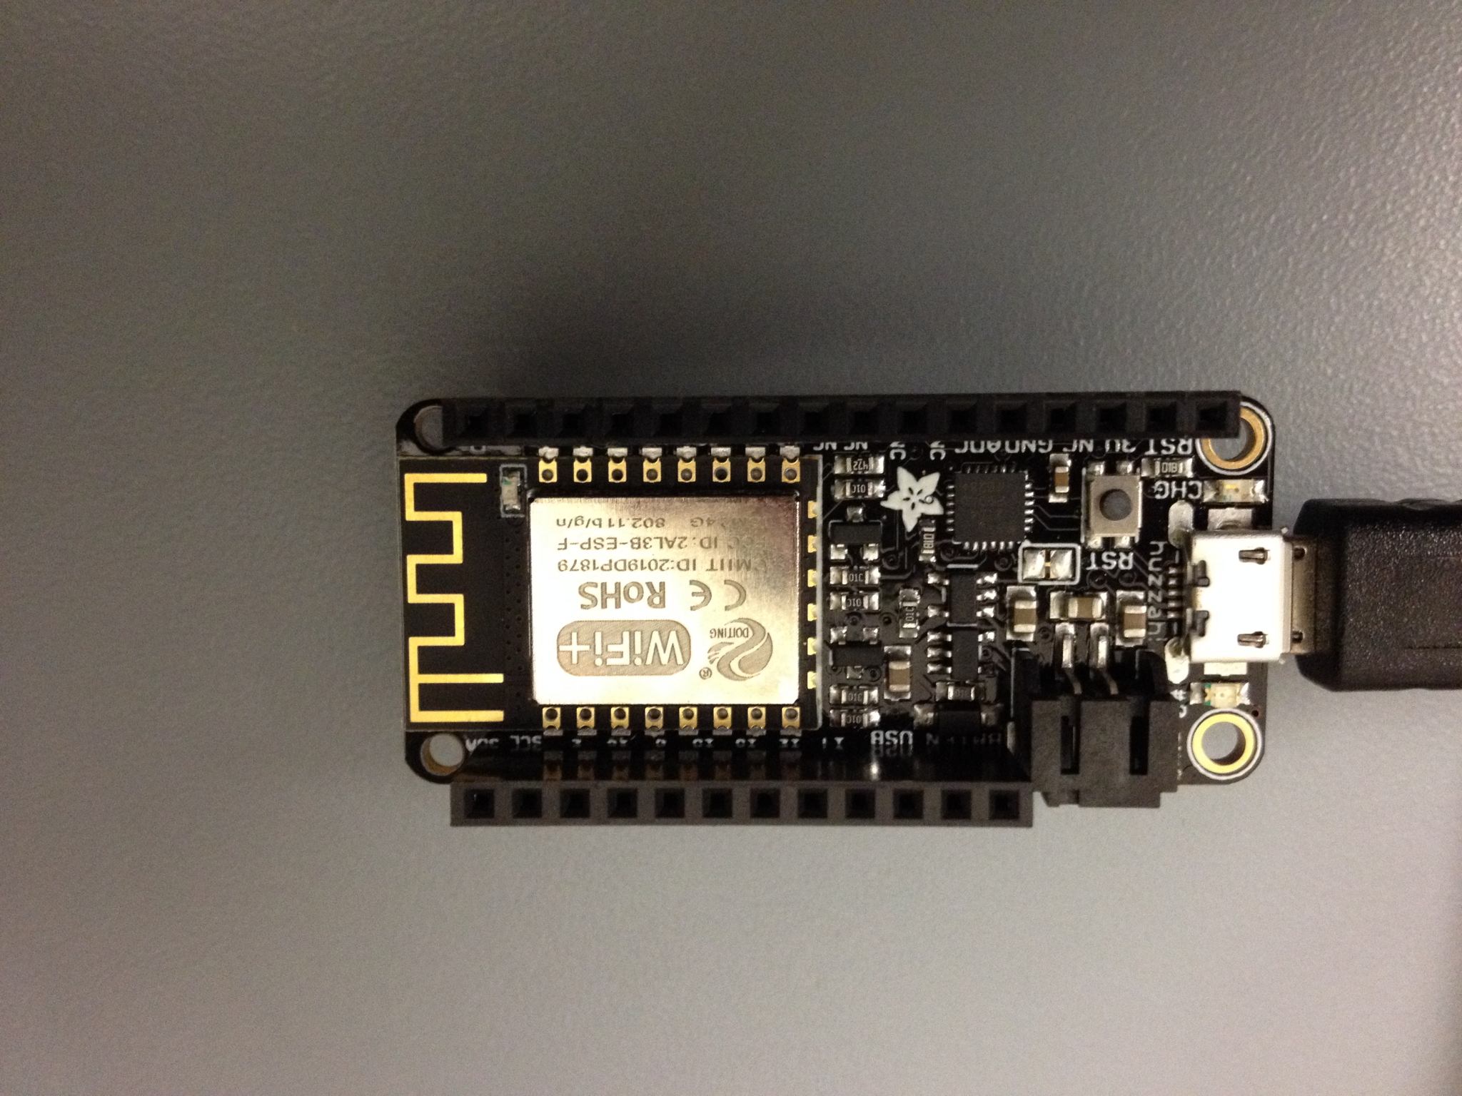

*Figure 2.7 and 2.8 The diorama uses an Arduino Mega 2560 microcontroller (left) and an Adafruit ESP8266 Huzzah Wifi Module (right).*

## Installation, setup, and support

The Future of Heat product is an educational tool that comes pre-built without the need for any further assembly. The user only needs to plug in the three pronged power plug, put in the AA and plug in the USB power cables for the Arduino microcontroller and the wifi module.

As this product utilizes internet connectivity, it would be optimal to position the product near a WiFi source, whether this be near a Wi-Fi router or a laptop hosting a mobile hotspot. Additionally as this diorama is made of 3D printed plastic mounted on foamcore, it is built strictly for viewing, as such it is recommended that children utilizing this learning tool avoid touching it.

The web application can be accessed by the user by simply visiting the project website via web browser [www.FutureOfHeat.com](http://www.futureofheat.com). For the hardware setup, the user should place the diorama on a table or any other stable location where users get good visibility. Additionally, dimming the lights is suggested as it offers better visibility of the diorama’s LEDs. Powering up the diorama includes three main components: the battery compartments, the standard three prong electric plug, and the USB cables. The battery compartment powers all of the LEDs on the diorama. 8 AA batteries should be placed in the two battery compartments found on the side of the diorama. Specifically, 4 AA batteries per battery compartment, and additionally check that the inserted batteries follow the noted polarities etched on the casing. Additionally, the battery cases have on and off switches that are used to conserve battery life, as such ensure that both switches are toggled on prior to starting up the product. The electric plug powers the diorama’s 12V AC transformer and should be plugged into a nearby wall outlet. The two USB cables power the Arduino microcontroller and the wifi module, these should be plugged into the corresponding laptop used to display the web app. Use a USB port extender if needed. Refer to *Figures 2.10, 2.11, 2.12* on page 10 for more information.

Lastly, in order to ensure that the Wifi module can connect to the internet in the Sustainability Hub building there are two possible options. Option 1 is to host a mobile hotspot named "ESP" with the password of "TeamHeat" on the 2.4 GHz frequency, option 2 is to alter the lines of code for the wifi network name and password in the source code and reupload it to the wifi module. The steps are as follows:

Option 1

1. By default any Windows 10 PC can utilize a mobile hotspot by sharing it’s Internet connection with other devices over Wi-Fi. As such if the adjoining laptop used to host the web app, has a Windows 10 operating system, it can be used to connect the Wifi module to the wifi network.
2. As such, turn on the hotspot and edit its Network name and Network password to be "ESP" and "TeamHeat" respectively. Additionally ensure that the Network band is at 2.4 GHz.

Option 2

1. If the adjoining laptop used to host the web app doesn’t have a Windows 10 operating system, head over and download the Wifi Module’s source code at: <https://github.com/BostonUniversitySeniorDesign/21-17-Future-of-Heat-Arduino/tree/main/ESP8266BasicTest1>
2. Download the free Arduino software needed to alter and reupload the code at this link: <https://www.arduino.cc/en/software>
3. Plug in the Wifi Module’s USB cable (the black one) into your laptop’s USB port.
4. Once the Arduino software is installed, create a new file, copy and paste the code from “ESP8266BasicTest1” but replace WIFI_SSID and WIFI_PASSWORD variables with the corresponding network name and password present at the Sustainability Hub. As the wifi module only operates on 2.4 GHz make sure that the chosen network can support 2.4 GHz devices.
5. Once edits are complete click the Tools option on the upper toolbar, ensure that the board listed is Adafruit Feather HUZZAH and the USB port is correctly selected. Upload the edited code and the wifi module should connect.

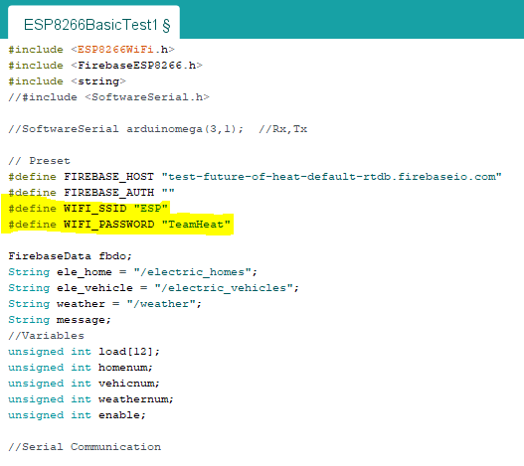

*Figure 2.9 ESP8266BasicTest1*

*Highlighted lines of code the user needs to edit in order ensure wifi connection.*

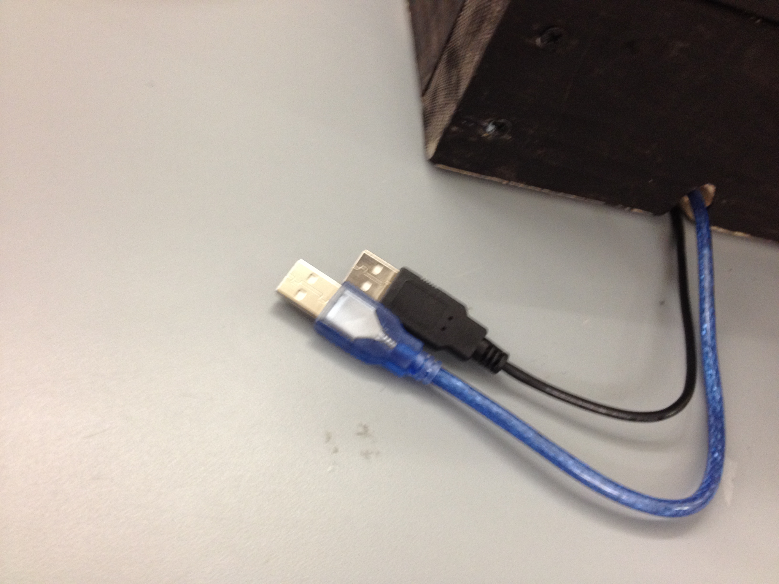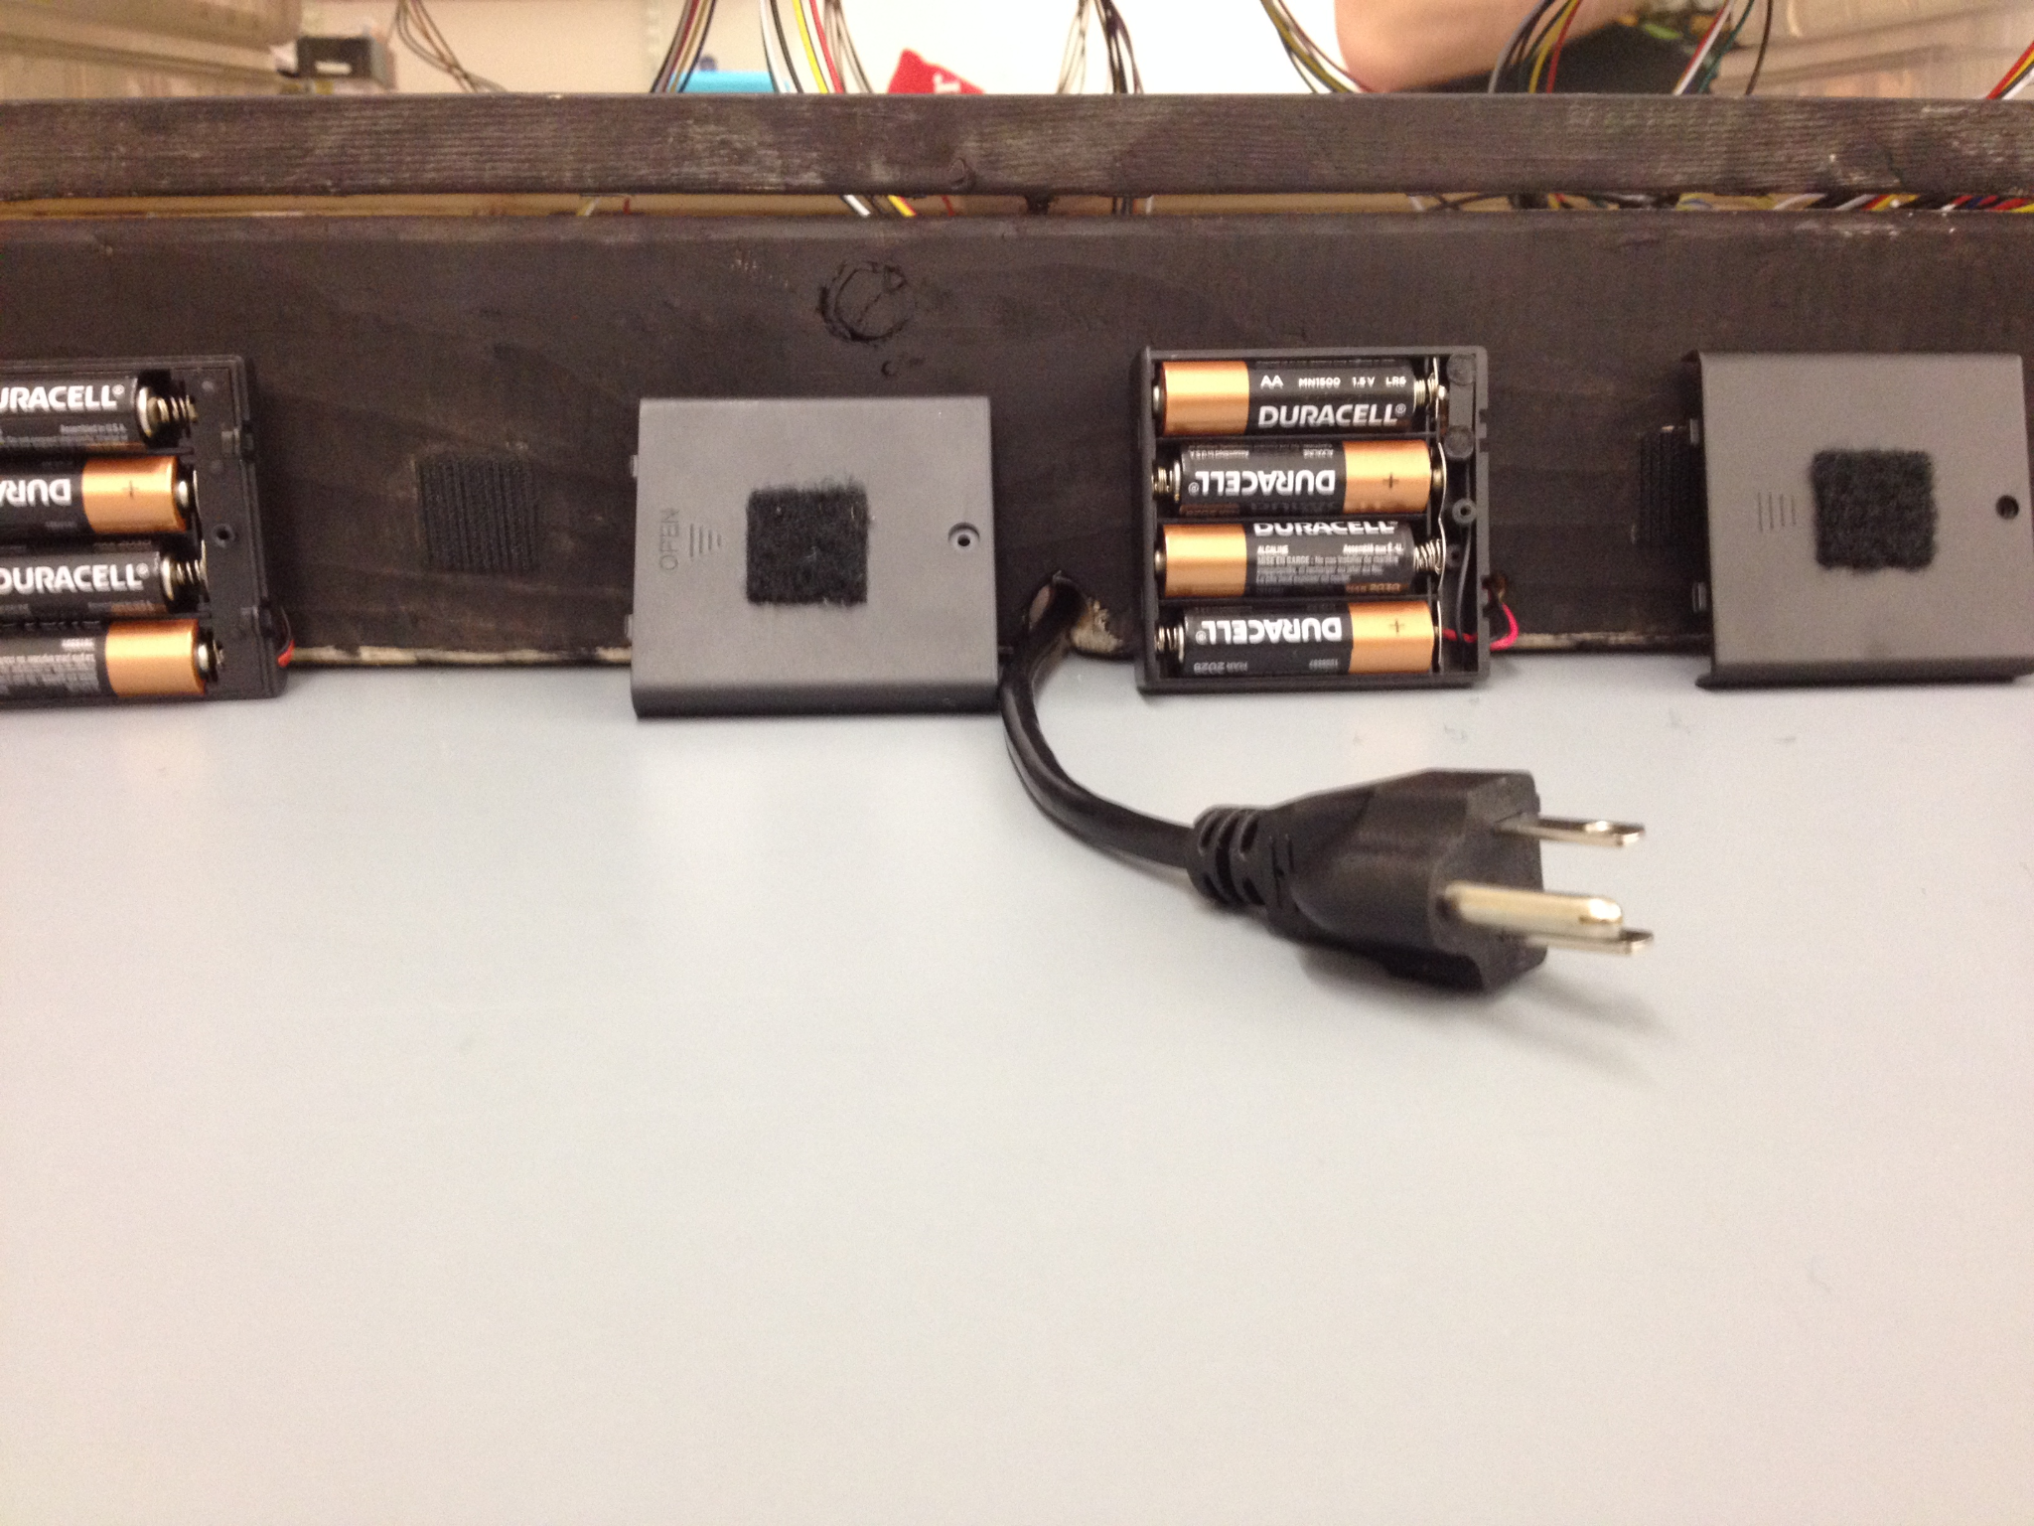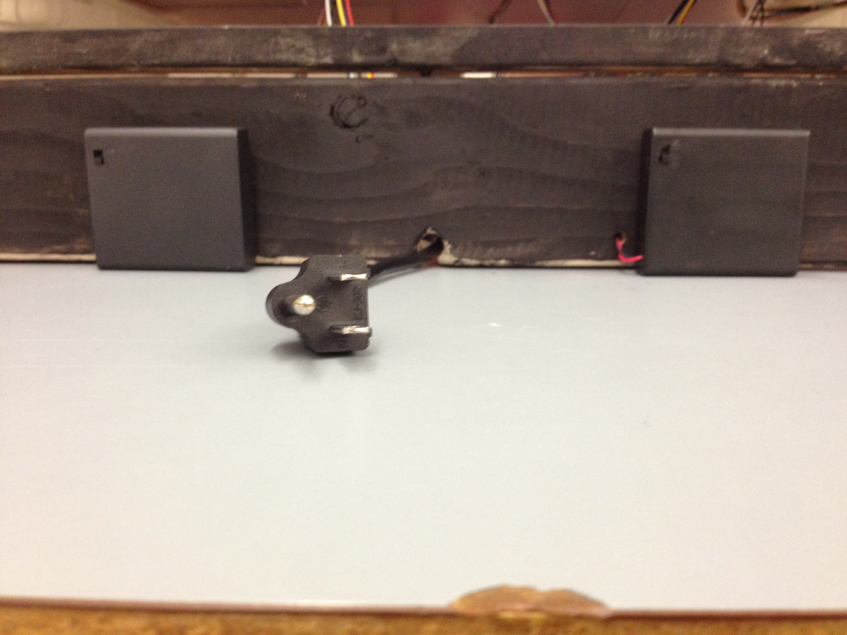

*Figure 2.10, 2.11, and 2.12 Powering Cables*

*Figure 2.10 (right) both of the USB cables for the Arduino Mega (Blue cable) and the Wifi module (Black cable). Figure 2.11 (center) presents the two battery compartments and the three pronged power plug. Figure 2.12 (left) shows the back sides of the battery compartments, as they are mounted on with velcro, one can easily flip the compartment around to replace batteries.*

# Operation of the Project

## Operating Mode 1: Normal Operation

In normal operating mode, a user will interact with the diorama as follows:

1. The user should visit the project website [www.FutureOfHeat.com](http://www.futureofheat.com).
2. The user selects inputs from the accompanying web application. These inputs are sliders for the adoption rates of electric heating from 0-100%, the adoption rate of electric vehicles from 0-100% and the lowest outside temperature from 0-50℉. The numerical values corresponding to the slider inputs are clearly shown for selection transparency.
3. Upon clicking enter for the user selections, the project will automatically proceed with the subsequent diorama LED changes.
4. There are two types of LEDs per house that will change to reflect user input. The LED mounted on top of each model house will toggle between red and green to indicate which houses have electric heating (green) and which houses have conventional gas heating (red). While the LED mounted within each house will gradually transition from blue to red to indicate houses heating up, this transition duration depends on the user’s temperature input.
5. While the LEDs change, data regarding the MWh usage, CO₂ emissions and energy pricing data for the model neighborhood will be presented on the web application. Note that the MWh usage graphs draw data from rescaled energy values read from a simplified resistive circuit meant to mimic consumer loads.
6. Should no further changes to the input be made the LED behavior on the diorama will begin to loop, following the previously entered inputs.

In this mode the user will only have the option to interact with the diorama through the web application as described above. If one follows the installation instructions as listed above, there should not be abnormal consequences of user actions.

## Operating Mode 2: Abnormal Operations

1. If the Red/Green LEDs on the house roofs of diorama all remain red and don’t correspond to the user input, it is most probable that there is a wifi connection issue. This suggests that the Wifi module isn’t sending the user inputs selected on the Web App to the Arduino. Simply move the diorama closer to the Wifi network router or mobile hotspot. If a mobile hotspot is used the user can check for Wifi connectivity by seeing the wifi module listed.
2. If none of the LEDs are turning on despite the fact that both of the battery compartments are filled and toggled on, it may be an issue that some of the batteries used are dead. Simply check the voltages on all of them and replace them with newer batteries.
3. If there are multiple consecutive different inputs for the diorama, it may be necessary to disconnect and reconnect power to the Arduino. Consecutive inputs are buffered, resulting in mismatched LED behavior with the most recent input. As such it is recommended that a staffed personnel oversee this educational model to ensure correct usage.
4. In the event of an electrical fire **DO NOT** use water!
   1. If the fire is small enough, you may extinguish it by:
      1. Carefully unplugging the diorama if it is safe to do so.
      2. Use a multipurpose fire extinguisher with C in its label, this is used for electric fires.
      3. Use baking soda or a heavy blanket to smother the flames if a fire extinguisher is unavailable.
   2. In the event of a large fire please exit the room immediately and call 911.

## Safety Issues

The inherent safety issues that surround this project are the electrical components of the diorama and the diorama itself. The diorama is powered by two 6V batteries as well as a 120V to 12V transformer. The circuitry is hidden under the diorama and properly insulated to ensure electrical safety. This product has only been tested to operate by 120 VAC at 60 Hz, by North American power standards. Operation under other countries’ power ratings is ill advised. Additionally users are suggested to use surge protectors on the outlet powering this device, as this product hasn’t been designed with power surges in mind.

Users should refrain from physically touching or tampering with the product, as this is a purely visual teaching tool. Improper handling may cause bodily damage/injury, especially due to the relatively high mA current. Avoid spilling liquids around the product as this may cause an electrical fire and or damage the electrical components. Should a fire occur follow the abnormal operation as listed above. Lastly, the diorama is a rather heavy and large product, as such it should be carried from the base by two people for transport.

# Technical Background

## Web Application

The project consists of a Web Application available via web browser. A real time database will be managed through Firebase’s services. The client will interact with Firebase servers to manage the user interactions with them. All data regarding the number of homes adopting electric heating, weather and individual house loads will be stored in Firebase’s database server.



*Figure: 4.1 The Deployment Diagram.*

*This figure consists of the client browser and the web services provided by Firebase. The application interacts with the data hosted in Firebase.*

The Firebase services component of the system provides back-end support to the application. Firebase provides a realtime database management service that can be accessed through the use of Node.js or HTTP requests. This will allow the application to store vital information in a decentralized location for easy access. [2]

At the beginning of the application use, the user is sent to a screen where they view the home page of the project. From here the user should ‘Click to Start’ to clear the database and begin testing. Next, the user can select a range of input values using the different range sliders. Clicking the ‘Enter’ button will update the database for the Arduino to read and the output graphs will be displayed.

1. future-of-heat - This tree contains five fields
   1. The active bit to inform the Arduino when the application is in use
   2. The number of homes adopting electric heat
   3. The number of electric cars
   4. A list of the house loads in the diroma
   5. The weather range
2. homes - This subtree contains the load value of all 12 buildings in the diorama.



*Figure: 4.2 The Dialog Map.*

*This figure shows the sequence of screens the user can transverse through in the Future of Heat application.*



*Figure: 4.2 Database Entity Diagram.*

*Firebase’s Realtime Database uses JSON object trees to store and organize data. This figure shows how the application database will be organized in one main tree and a sub-tree for each individual house load.*

## Circuitry

The team decided to design the circuit to operate under alternating current conditions. In order to control the adoption rates of electric heating and vehicles, we implemented SSR PhotoMOSFETs to gain bidirectional control over the current. The aforementioned device works using an input voltage to turn on a photodiode that in turn, biases the gates of the MOSFETs to allow current flow in both directions. Thus, by using an analog output from the Arduino and connecting it to the relay input, we get full control over the current in the relay output branch. Building up from here is simple. Each house unit has three loads:

* First is the main load that is always on (no relay control) which models the average energy consumption of an American home, excluding heating
* Second is the electric heating load which is controlled with a relay
* Third is the electric vehicle load which is also controlled with a relay

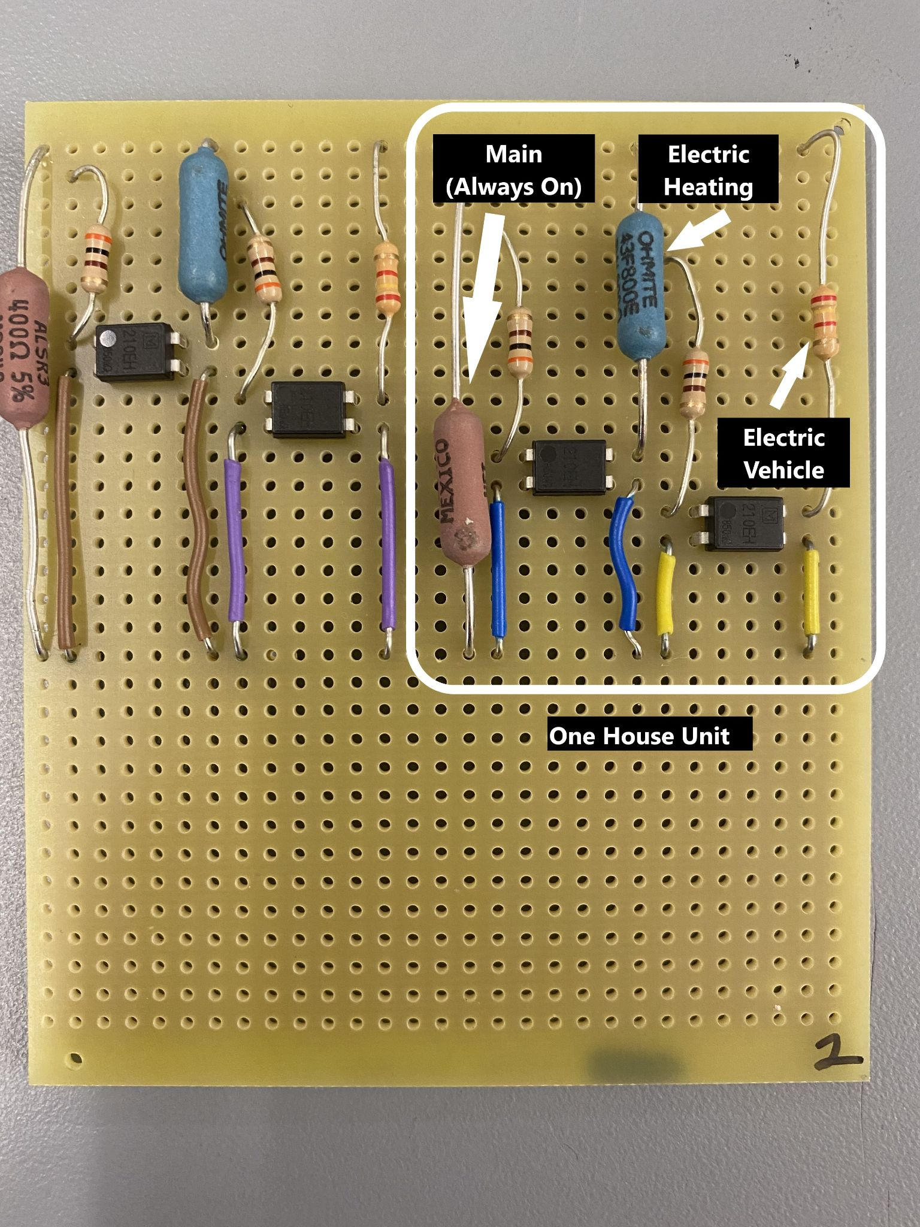

*Figure 4.4 : Two House Units*

Depending on the adoption rates of electric heating and vehicles, some house units will have one resistor branch (minimum power consumption), some will have two resistor branches, and others will have three resistor branches (maximum power consumption). In addition to the 11 house units, there is 1 hotel unit which is equivalent to 6 house units. The hotel unit operates very similarly to the house unit. The only difference is that it consumes 6 times greater power and the electric heating load consists of 2 groups of 3 resistors where each group is controlled by its own relay. The reasoning for the grouping is to remain below the maximum current threshold of the relay (129 mA peak, where the relay is rated for 130 mA peak). If all 6 electric heating resistors were to channel through a single relay, the current would overwhelm the relay, causing it to burn out. As for the power source for the 120 V to 12 V (50 VA) step-down transformer it is connected to a US standard three-prong power cord. All parts of the circuitry are powered by this transformer, except for the relay inputs which are controlled by Arduino pins.

## Arduino + ESP8266 Wifi Module:

This portion consists of the Arduino Mega, ESP8266 wifi module, the two sets of bicolor LEDs, Red/Blue and Red/Green. The ESP8266 Wifi Module functions as an interface between the Arduino and the Web App, receiving users inputs from the web app and transmitting them to the Arduino. The Arduino in turn uses these inputs to correctly output the necessary LED behavior as seen on the diorama. Additionally these inputs are also used in control logic for the relays in the circuitry. As all the house loads are in parallel, only one voltage value needs to be empirically measured. From there, calculated power loads will be transmitted from the Arduino to the ESP8266 which can then be written directly to the FireBase Realtime Database’s house loads tree. A general block diagram of the described functionality can be seen below.

*Figure 4.5 Block Diagram of Arduino+ESP8266 Functions*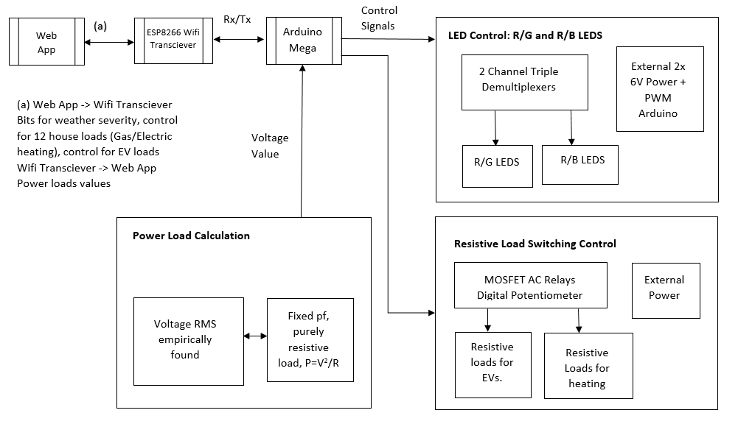

*Note that there are three distinct functions that the Arduino carries out, LED control, resistive load switching, as well as power load calculations. Additionally the Arduino is strictly used for control signals and as such doesn’t power any components at all.*

# Relevant Engineering Standards

**Safety standards:**

* Wire insulation, product surface temperatures and electrical circuit design follow the Electronic Code of Federal Regulation: [Part 1505— REQUIREMENTS FOR ELECTRICALLY OPERATED TOYS OR OTHER ELECTRICALLY OPERATED ARTICLES INTENDED FOR USE BY CHILDREN](https://www.ecfr.gov/cgi-bin/retrieveECFR?gp=&SID=0adfd3e71ab0625edd390ddf250898ff&mc=true&n=pt16.2.1505&r=PART&ty=HTML)
* All components used in manufacturing this product are ROHS compliant.
* Project is designed to meet the National Institute for Occupational Safety and Health (NIOSH) recommended lifting equation in mitigating the hazards of back injuries. The diorama weighing in at 25 lbs is designed to be safely carried by two average people.

**Web Application standards:**

* All communication between the Auth servers and the core application is done in compliance with SSL protocol.

**Arduino and Wifi Module standards:**

* The ESP8266 Wifi Module interfaces with the web app in compliance with IEEE 802.1 internetworking management standards.
* Code for the Arduino control is strictly in compliance with ISO/IEC 14882:2017 (ISO-C++), following the strict requirements for implementations of the C++ programming language.

# Cost Breakdown

|  |  |  |  |  |  |
| --- | --- | --- | --- | --- | --- |
| Project Costs for Production of Beta Version (Next Unit after Prototype) | | | | | |
| **Item No.** | **Item Name** | **Qty.** | **Description** | **Unit Cost** | **Extended Cost** |
| 1 | SSR Relay | 25 | Toggle switch for load units | $3.10 | $77.50 |
| 2 | Breadboard PCB | 7 | To assemble the circuitry | $5.85 | $40.92 |
| 3 | 800 Ohm Res | 11 | Models electric heating | $1.46 | $16.03 |
| 4 | 400 Ohm Res | 21 | Models main load | $1.40 | $29.30 |
| 5 | 2400 Ohm Re | 11 | Models electric vehicles | $1.86 | $20.46 |
| 6 | 300 Ohm Res | 25 | Current limiter for relay input | $0.80 | $20.00 |
| 7 | 120 V - 12 V Transformer | 1 | Steps down the wall socket voltage to 12 volts | $16.35 | $16.35 |
| 8 | Power cord | 1 | Draws power from the wall socket | $8.95 | $8.95 |
| 9 | 2*4 wood planks | 4 | Used to create the diorama base | $2.39 | $9.56 |
| 10 | Insulation foam | 2 | Used to fill in gaps in the diorama base for a smooth surface | $25.00 | $50.00 |
| 11 | SLA Resin | 3 | Create diorama buildings | $37.00 | $111.00 |
| 12 | Arduino Mega | 1 | Microcontroller for LEDs + relays | $38.50 | $38.50 |
| 13 | HUZZAH ESP8266 | 1 | Wifi Communication | $19.95 | $19.95 |
| 14 | Demultiplexer | 8 | Multiplex Arduino signals | $0.47 | $3.75 |
| 15 | Red/Blue LED | 12 | Indicates homes heating | $0.41 | $4.92 |
| 16 | Red/Green LED | 12 | Indicates electric/gas heating | $0.31 | $3.66 |
| 17 | 330 Ohm Res | 48 |  | $0.10 | $4.88 |
| Beta Version-Total Cost | | | | | $475.73 |

The main expense and constraint of the project was constructing all of the 3D printed houses out of PLA resin. 3D printing with liquid resin is quite expensive, even more so given that 11 houses, 1 hotel and 1 power plant needed to be printed.

The cost of software was reduced through the use of free hosting on FireBase and a free version of Arduino IDE.

# Appendices

## Appendix A - Specifications

|  |  |  |
| --- | --- | --- |
| **#** | **Specification** | **Description** |
| **Circuit** | | |
| 1 | Voltage | The circuitry has a voltage of 13.8 V rms |
| 2 | Variable Loads | 12 load units with 24 voltage-controlled resistor branches |
| 3 | Step down transformer | One step down transformer: 120V wall socket to 12V circuit input |
| **Web Application** | | |
| 1 | Inputs | 3 user inputs: home and vehicle adoption rates and weather |
| 2 | Outputs | CO2 emissions, cost and energy consumption graphs |
| **Arduino** | | |
| 1 | Visuals | 12 R/B LEDs to indicate gas or electric heating  12 R/G LEDs to indicate houses heating up |
| 2 | Input to Output Delay | ~3 seconds |
| **Diorama** | | |
| 1 | Building count | 11 residential buildings, 1 hotel, and 1 power plant |
| 2 | Cavity for circuitry | A cavity must be present in the diorama so circuitry can be stored away from users |
| 3 | Weight | The diorama weighs 25lbs |
| 4 | Size | 3’ x 3’ |

## Appendix B – Team Information

* **Muayad Al Riyami:** I am a senior Electrical Engineering student. After graduation, I will be applying for jobs in the US to gain work experience for two years before going back to Oman. I am the kind of person who goes with the flow, so I do not have a long term plan.
* **Seunghak Shin:** I am an Electrical Engineering senior who’s currently looking for a job. Ideally, I would like to work in the energy industry, especially renewable energy as I see it as one of the most important fields in the near future.
* **Andrew Chen:** I am an Electrical Engineering senior. I will be pursuing PE licensure and hopefully employment in the power industry.
* **Fatima Dantsoho:** I am a computer engineering senior and I will be pursuing a Masters of Science degree in Computer Engineering after graduating.
* **Ben Gross:** 5th year Electrical Engineering student graduating by the end of Summer 2021. I plan on looking for a job in the renewable energy field. I hope to be working the electronics side of any project I get assigned to but I'm willing to take up other posts and work diligently at them.

## Appendix C – References

[1] Google Firebase. Firebase, 2017

[2] Anant Narayanan. Where does firebase fit in your app, 2015.